**Project Documentation**

**InsightStream: Navigate the News Landscape**

**Introduction**

* **Project Title:** InsightStream: Navigate the News Landscape
* **Team ID:** NM2025TMID37460
* **Team Leader:** Saraswathi S (sivakumarpoornaganapathi@gmail.com)
* **Team Members:**

- Pavithra R(pavithrarajkumar09@gmail.com)

- Poornima V(Poornimav2407@gmail.com)

- Sarjana P(iamsarjana.2007@gmail.com)

**Project Overview**

**• Purpose:**

The purpose of this project is to build a modern and user-friendly news application that enables users to stay updated with current events, while delivering accurate and relevant content in a seamless and engaging manner. It focuses on offering a fast, responsive, and intuitive interface for an enhanced user experience, and by utilizing the latest web technologies, the project ensures timely access to information anytime and anywhere.

• **Features:**

* Personalized News Feed
* Real-time Notifications
* Bookmark & Save Articles
* Multimedia Support
* Share Art

**Architecture**

* **Frontend:** React.js with Bootstrap and Material UI to create a responsive, interactive, and user-friendly interface for reading and navigating news.
* **Backend:** Node.js with Express.js to manage server-side logic, handle API requests, and serve news content efficiently.
* **Database:** MongoDB to store user profiles, preferences, saved articles, feedback, and other application data.

**Setup Instructions**

* **Prerequisites:**

– Node.js

– MongoDB 1

– Git – React.js

– Express.js – Mongoose – Visual Studio Code

* **Installation Steps:**

1. Clone the Repository: - Open a terminal or command prompt and navigate to the directory where you want to clone the repository. - Run the command: git clone https://github.com/[username]/insight-stream.git - Replace [username] with the actual GitHub username or organization name.
2. Install Dependencies: - Navigate to the cloned repository directory: cd insight-stream - Run the command: npm install - This will install all the required dependencies listed in the package.json file.
3. Configure Environment Variables: - Create a .env file in the root directory of the project. - Add the following environment variables: - REACT_APP_API_KEY: The API key for the News API - REACT_APP_BASE_URL: The base URL for the API requests - Replace the placeholder values with your actual API key and base URL.
4. Start the Development Server: - Run the command: npm start - This will start the development server, and you can access the application at http://localhost:3000 Environment Variables:

- REACT_APP_API_KEY: The API key for the News API

- REACT_APP_BASE_URL: The base URL for the API requests

Troubleshooting:

- If you encounter any issues during the installation process, try deleting the

node_modules directory and running npm install again.

- If you encounter any issues with the development server, try checking the console logs for

errors or restarting the server.

**Folder Structure**

Client:

The React application is organized into the following folders:

- components: Reusable UI components used throughout the application

- Header.js: The header component with navigation and search bar

- Footer.js: The footer component - NewsCard.js: The individual news article

components

- SearchBar.js: The search bar component

- pages: Components that represent individual pages or routes

- Home.js: The home page component that displays the news feed

- Category.js: The category page component that displays news articles for a specific category

- SearchResults.js: The search results page component that displays news articles matching the search query

- assets: Static assets used in the application

- images: Folder for image assets

- fonts: Folder for font assets - utils: Utility functions and custom hooks used in the project

- api.js: A utility function for making API requests

- helpers.js: A utility function for formatting dates and other helper functions

- context: Context API files for state management

- NewsContext.js: The context API file for managing news articles state Utilities:

- Helper Functions:

- formatDate: A function for formatting dates

- truncateText: A function for truncating text

- Custom Hooks:

- useNews: A custom hook for fetching news articles

- useSearch: A custom hook for handling search queries

**Running the Application**

**• Frontend:**

1. Open terminal → cd client
2. Run npm start
3. Server runs on [http://localhost:3000](http://localhost:3000/)

**• Backend:**

1. Open terminal → cd server
2. Run npm start
3. Backend API runs at [http://localhost:5000](http://localhost:5000/)

• **Access:**

1. Open a browser
2. Visit [http://localhost:3000](http://localhost:3000/)
3. Use InsightStream with backend connected

**API Documentation**

* **User:**

-/api/user/register – Register a new user

-/api/user/login – User login

* **Projects:**

-/api/projects/create – Create a new project

-/api/projects/:id – Get project by ID

* **Applications:**

-/api/apply – Apply to a project

* **Chats:**

-/api/chat/send – Send a chat message

-/api/chat/:userId – Get chats by user ID

**Authentication**

* JWT-based authentication for secure login
* Middleware used to protect private routes

**User Interface**

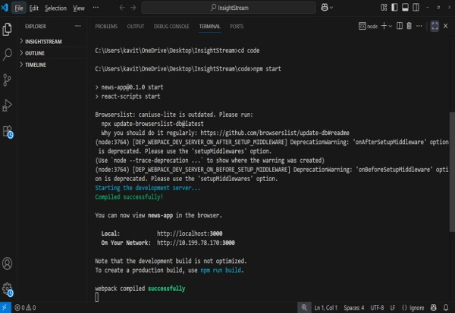

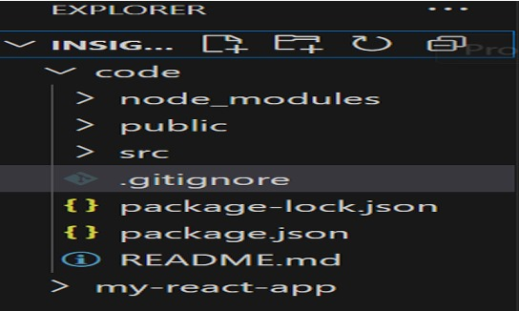

### 

**Testing**

* Manual testing at each milestone
* Tools: Postman, Chrome DevTools

**Screenshots**

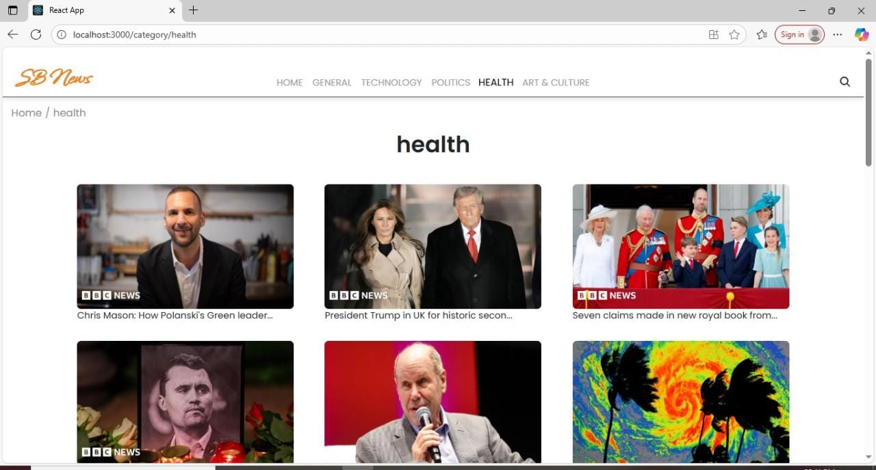

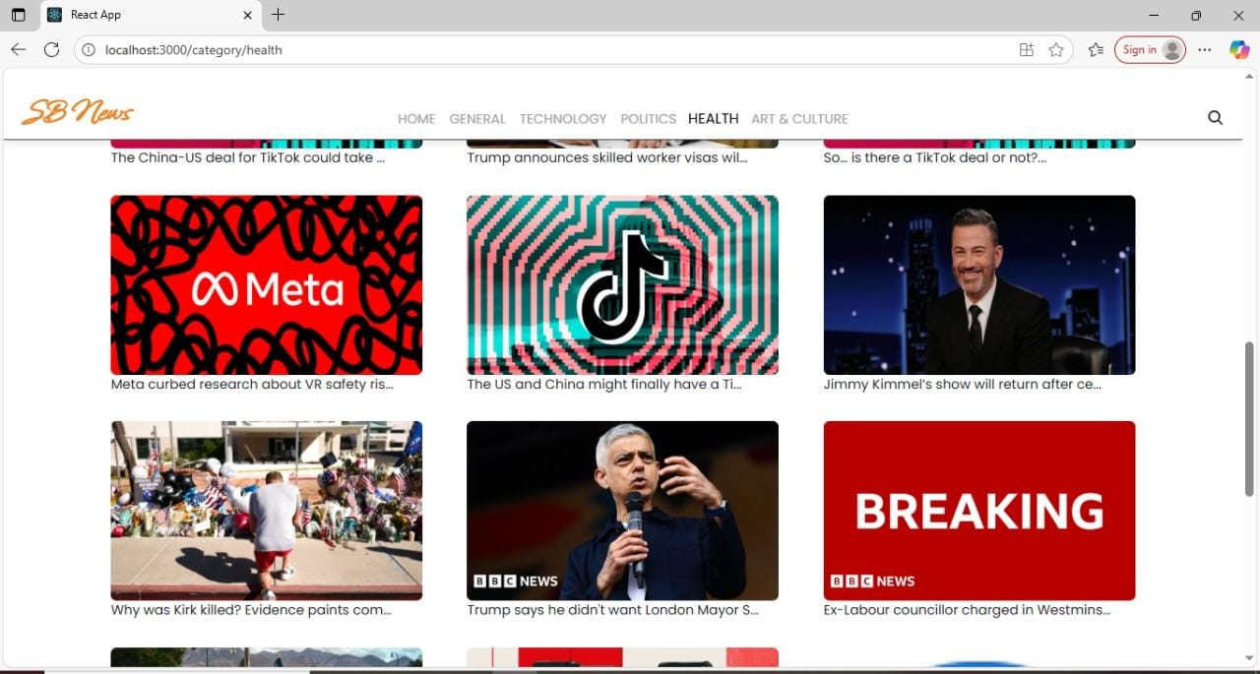

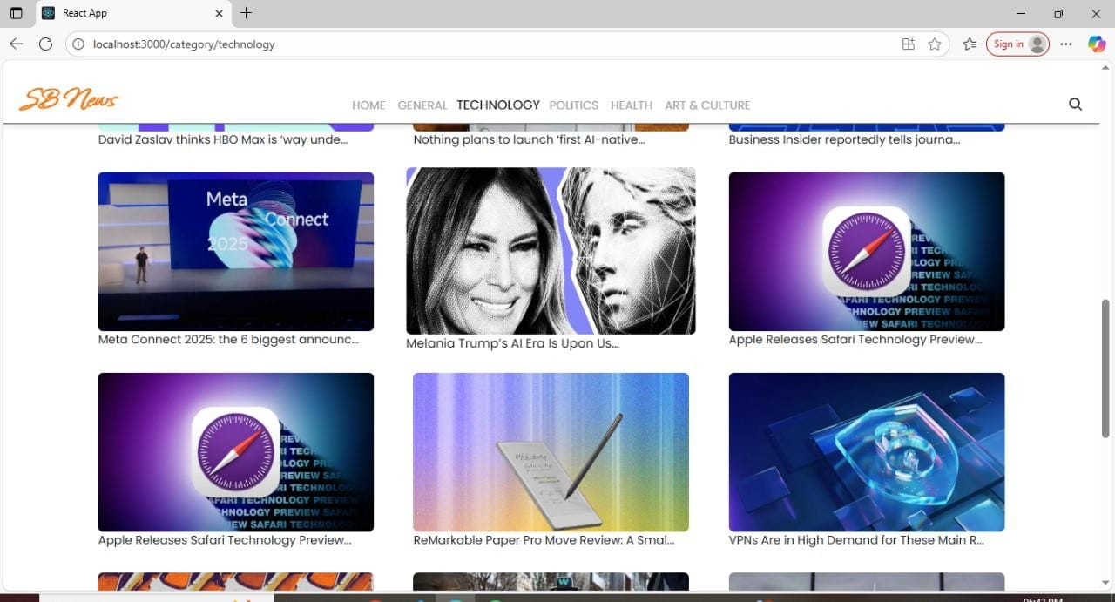

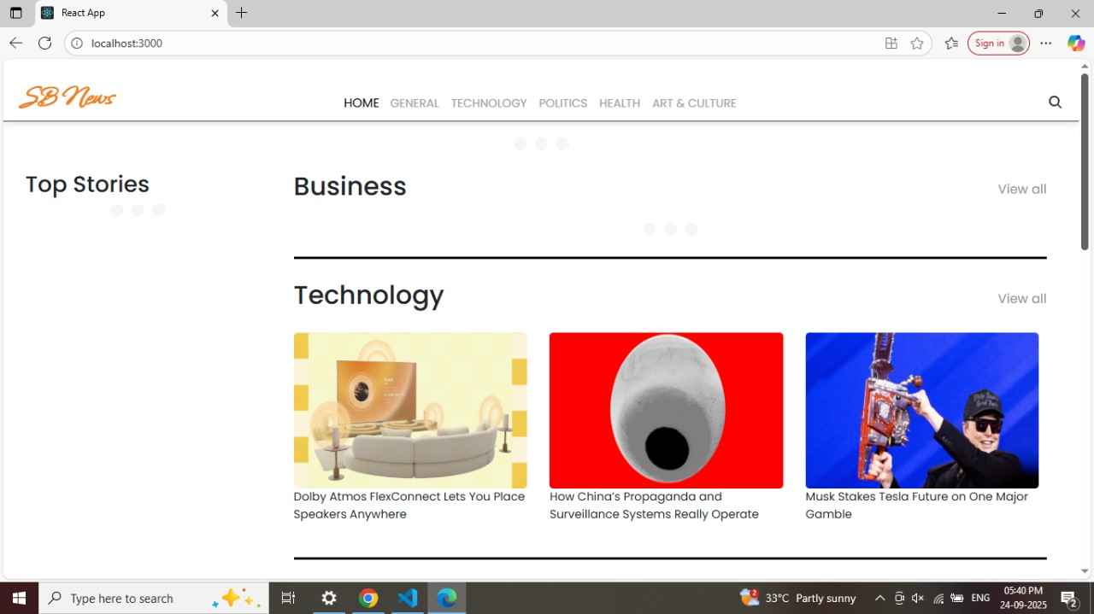

**Known Issues**

* **Loading Delays:** Some news articles or multimedia content may take longer to load during peak traffic periods or with slow internet connections, affecting the user experience.
* **Offline Reading Limitations:** The offline reading feature may not function properly for all types of content, such as videos or dynamically loaded articles, limiting its usability.
* **Notification Delays:** Real-time notifications may experience slight delays under certain network conditions or server load, which could result in users receiving breaking news alerts later than expected.
* **Search Accuracy:** The search functionality may occasionally return less relevant results for niche topics or newly published articles, making it harder for users to find specific news items.
* **UI/UX Inconsistencies:** Minor user interface inconsistencies may appear on different screen sizes, devices, or browsers, affecting layout and readability.
* **User Profile Sync Issues:** Changes to user preferences, saved articles, or bookmarks may not sync instantly across multiple devices in some cases.
* **Backend Limitations:** Under heavy load, the backend server may experience slower response times, impacting the speed of content delivery and chat features.

### **Future Enhancements**

* **AI-Powered Personalization:** Implement machine learning algorithms to provide more accurate and dynamic content recommendations based on user behavior and preferences.
* **Multi-Language Support:** Add support for multiple languages to cater to a wider, global audience.
* **Advanced Search & Filters:** Enhance search functionality with filters for categories, date ranges, sources, and trending topics.
* **Push Notifications & Alerts:** Improve notification system to include personalized alerts for breaking news and favorite topics.
* **Offline Mode Expansion:** Extend offline reading to include multimedia content such as videos and interactive infographics.
* **Dark Mode & Accessibility:** Introduce customizable themes and accessibility features for better readability and user comfort.
* **Social Media Integration:** Enable seamless sharing of news articles across multiple social media platforms.
* **Analytics Dashboard:** Provide users and admins with insights into reading habits, popular content, and engagement metrics.